Relational Databases with MySQL Week 1 Coding Assignment

**Points possible:** 70

|  |  |  |
| --- | --- | --- |
| Category | Criteria | % of Grade |
| Functionality | Does the code work? | 25 |
| Organization | Is the code clean and organized? Proper use of white space, syntax, and consistency are utilized. Names and comments are concise and clear. | 25 |
| Creativity | Student solved the problems presented in the assignment using creativity and out of the box thinking. | 25 |
| Completeness | All requirements of the assignment are complete. | 25 |

**Screenshots of Queries:**

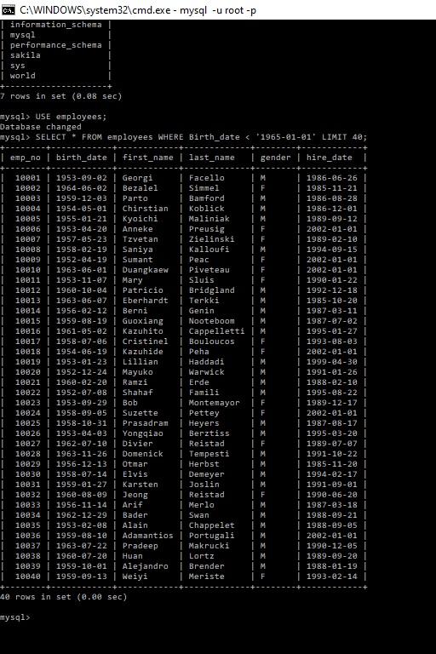 **1**

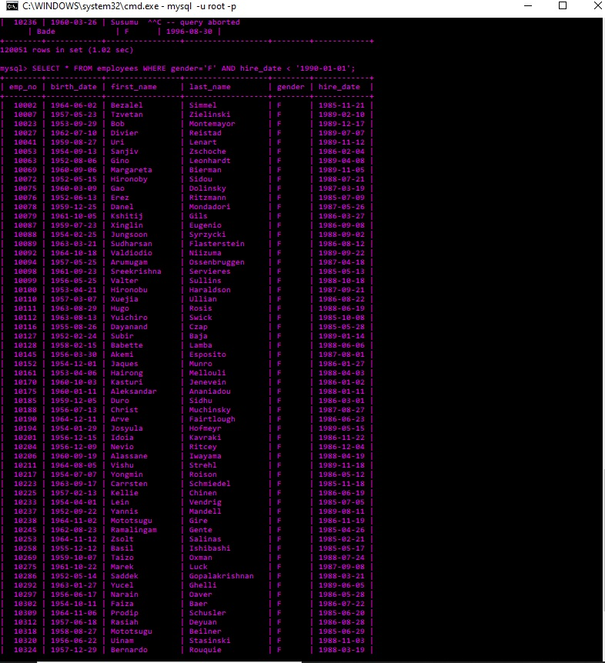 **2**

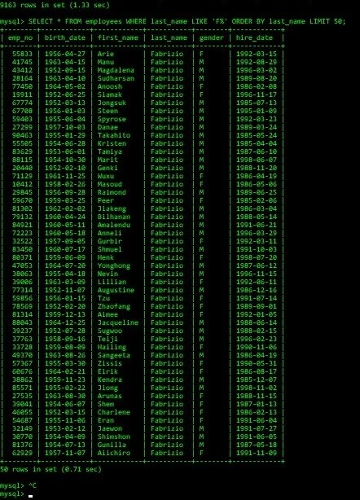 **3**

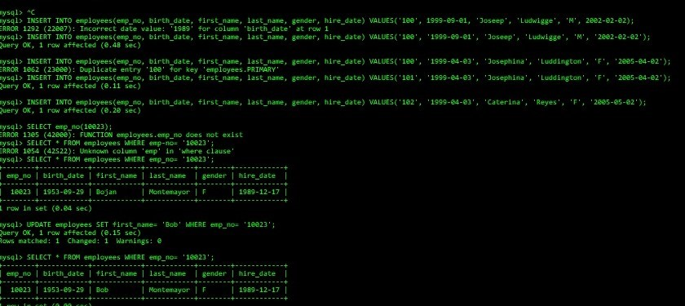**4, 5**

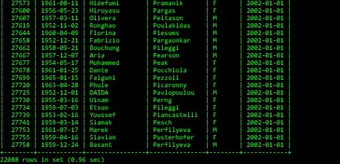 **6**

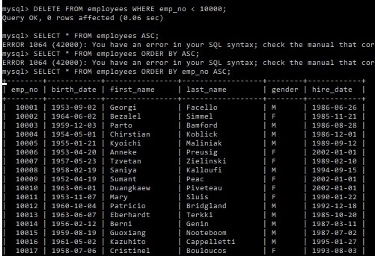 **7**

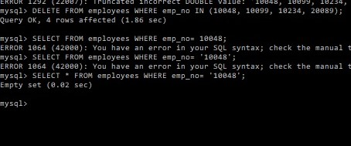

**Screenshots of Query Results (only include the last 20 rows):**

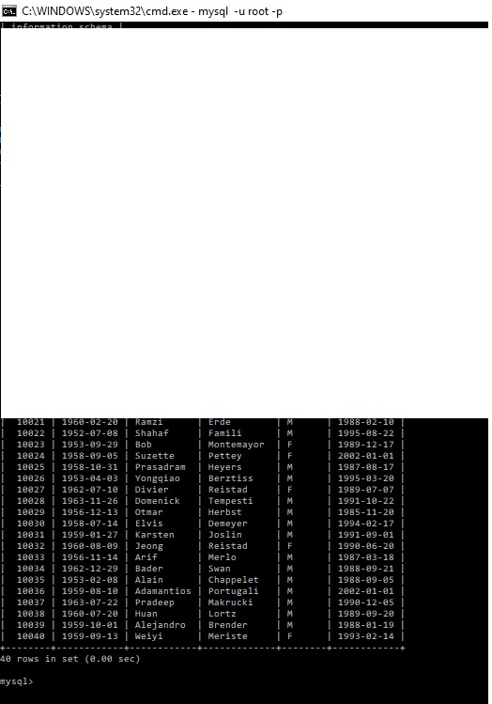



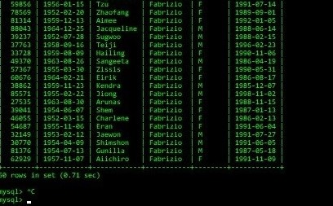









**URL to GitHub Repository:**

**https://github.com/JLudwigM/MySQL-Assign1.git**